Krathong Floating boats

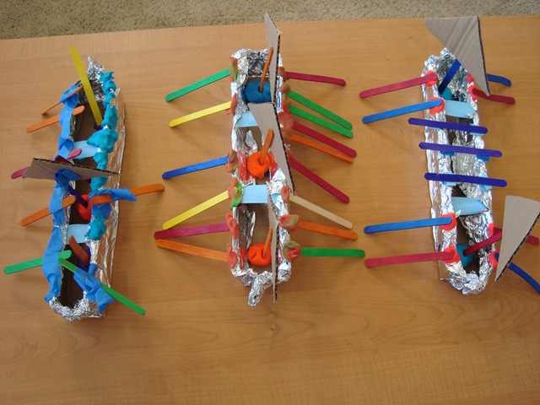

**Supplies:**

* Cardboard
* Masking Tape
* Tin Foil
* Popsicle sticks and any other decorating items you’d like
* Play-doh *(optional: we used it to secure the popsicle sticks that were holding up the sails)*

**Directions:**

**STEP 1:**Cut a rectangle out of cardboard and fold in each side so it makes a “U” shape as below. I used masking tape to hold it in place.

[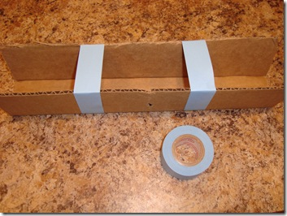](http://lh3.ggpht.com/__PNkZ0hVKgg/TMj2r1dj8VI/AAAAAAAAEsw/bQj-Cqd_7WI/s1600-h/DSC029162.jpg)

**STEP 2:** Cover the boat with tin foil, making sure to pinch ends together in a pointy shape to keep water from getting into boat.

[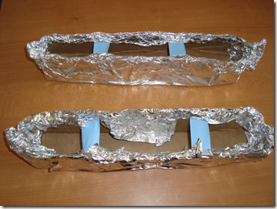](http://lh4.ggpht.com/__PNkZ0hVKgg/TMj2s2sIc2I/AAAAAAAAEs4/TbrhHSFHOC4/s1600-h/DSC029172.jpg)

**STEP 3:** Using popsicle sticks and whatever else you like, decorate your boat. We used the sticks for oars and also to hold up our sails. We placed a small ball of play-doh inside the boats and stuck the sail popsicle sticks into it.

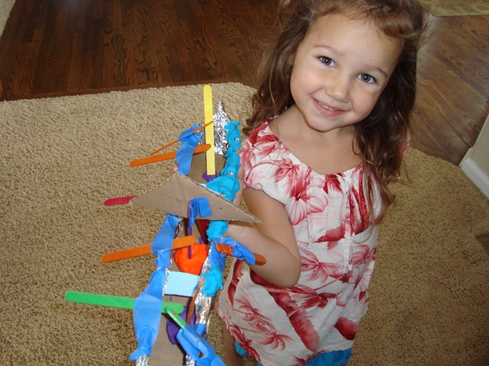

**Step 4:** Test out the boats to see if they float! If you want to be more authentic in your [Thailand Krathong Boat Festival](http://www.thaismile.jp/FotoGallary/ThaiPics/e_ThaiPhoto_LoyKraThong.html), you can add a small candle to the boats and float them at night!

[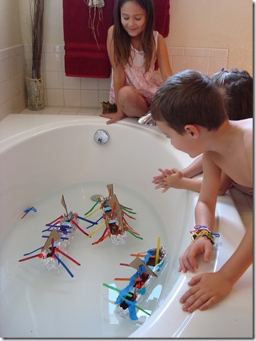](http://lh3.ggpht.com/__PNkZ0hVKgg/TMj2zLFqSHI/AAAAAAAAEto/-fEDPznY_ec/s1600-h/DSC02932%5B3%5D.jpg)